Doxy.me guide to video consults

How to carry out a video consultation
Open video consults  Open the video consultation site by clicking on VIDEO CONSULTS in the favourites bar of your chrome browser | 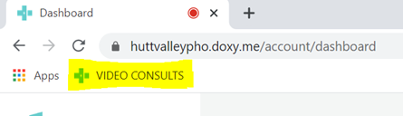
Arrive patient  When a patient arrives for their video consultation, their name will appear on the left side of your dashboard.  You will also be able to see how many minutes they have been waiting.  - Click on the patients’ name when you are ready to start the consultation  - The patient will appear on your screen and you can carry out your consultation | 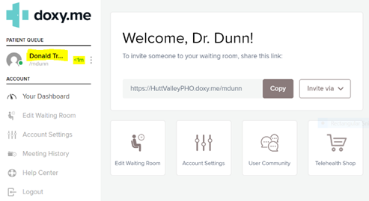
Connecting with your patient  - Be sure to look at your camera every now and then to connect with your patient as it can be off putting if eye contact is not made.  - If you do not recognise the patient, ask for two forms of identification.  See right hand example of an introduction when starting a video consultation with your patient | Hi Bob,  Nice to see you today. Before we get started there’s just a couple of things to let you know.  - If our connection cuts out, I will either start the consultation again from my end or phone you back.  - In order to be able to hear and see you well, can you please place yourself in a well lite, quite space and try to avoid walking around.  - Lastly, if you notice I am not looking at you at times, this will be because I am looking at my consultation screen as I would be if we were seeing each other in person.
Screenshare  - To share your screen or the patients screen, click on the Screenshare option on the left-hand side  - Select either Share my screen or Request patients screen | 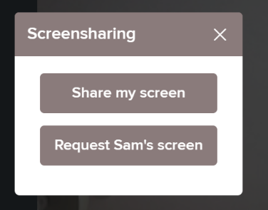  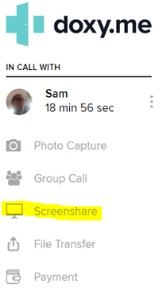

Photo Capture  - To take a screen shot ask the patient to show the specific area of their body you would like to capture  - Press Photo Capture and the photo will appear. Click on Download Image and save to your chosen place. | 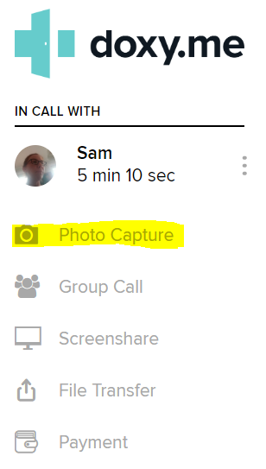  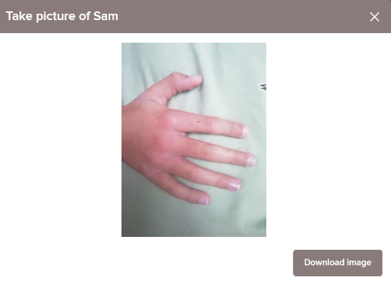
Chat / Message  You have the ability to message your patient. Helpful if you are running late. To do this:  - Click on the 3 vertical dots  - Select Chat  - A chat window will appear on the right side of your screen. Type your message in the text box and press Send | 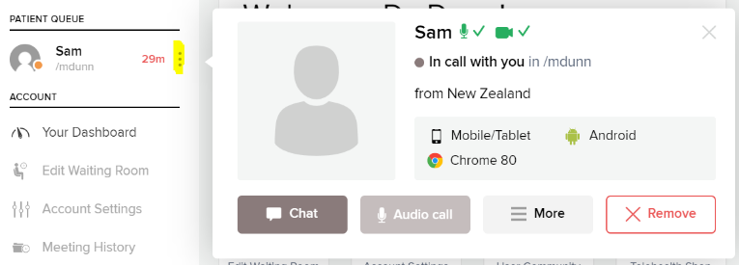  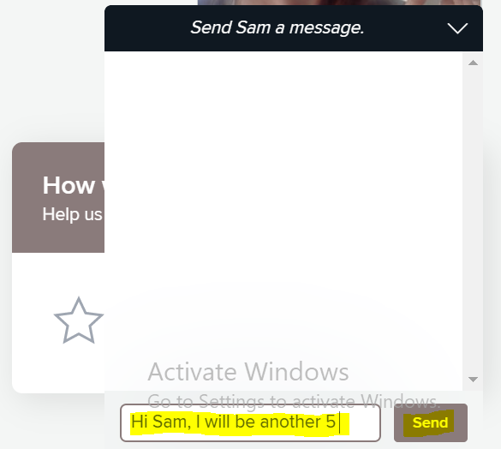
End Consult  To end the consultation simply click the red hang up button | 